1. **Questions**
2. How many single vs multiple-functions rooms were used last year in each of our resorts?

Answering that question will help us in identifying if we should have more or less of differemt kinds of rooms. If we noticed that multiple-function rooms were used more than expected, then we need to have more of those as they serve very well as a backup for any emergency situations especially during high-demand seasons where we don’t have enough sleeping rooms or meeting rooms for guests. Accordingly, this will significantly affect our bond with customers in a good way since we can always host them no matter how busy our reservations are, which will avoid them going to any other competitors hotel where they have vacant rooms. However, if we noticed that multiple-function rooms were barely or not used all, then we know we do not need to build more of them in the future buildings/constructions which will improve our budget since they cost more money than normal single-use rooms because of design and foldable items.

1. How many reservations have customers made with each of our resorts for a specific period i.e. last 2 years?

Answering that question will help us in building something like a rewards program/system that will help in both retaining our frequent customers and attracting new customers to be frequent ones by giving them free stays or discounts for their stays. Therefore, those customers would feel more valuable and appreciated to have their business and trust that will even encourage them to invite other people from their connection to try our resorts. That’s, retaining our current customers and attracting new ones to our business.

1. How many reservations were made because of events we hosted during a specific period vs another period i.e 2011-2015 vs 2016-2020 at any of our resorts?

Answering that question will help us in knowing how well we are doing with marketing and advertising for our resorts through events. This will also help us in knowing our guests more. For example, if we hosted a musical event, and we noticed it had bigger numbers of reservations than a sports event, this means that we need to focus more on musical events than sports ones. I believe knowing our guests interests are very important to know how to bring them back after their stays.

**2. Data Warehouse Snowflake schema**

**a. ER Models**

**i. RoomTypeReservationsFact**

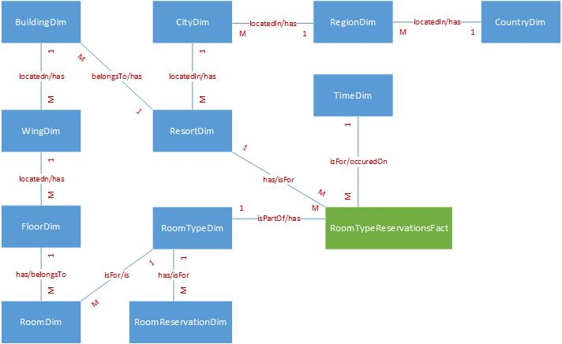

**ii. CustomerReservationsFact**

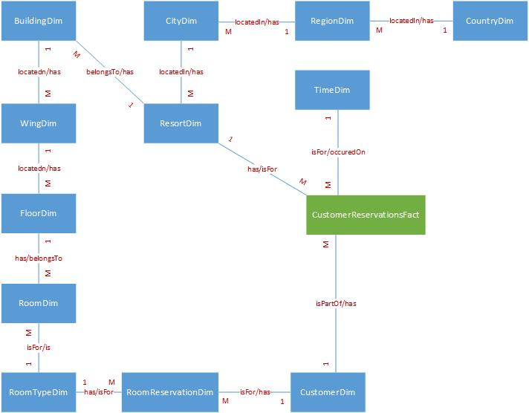

**iii. EventReservationsFact**

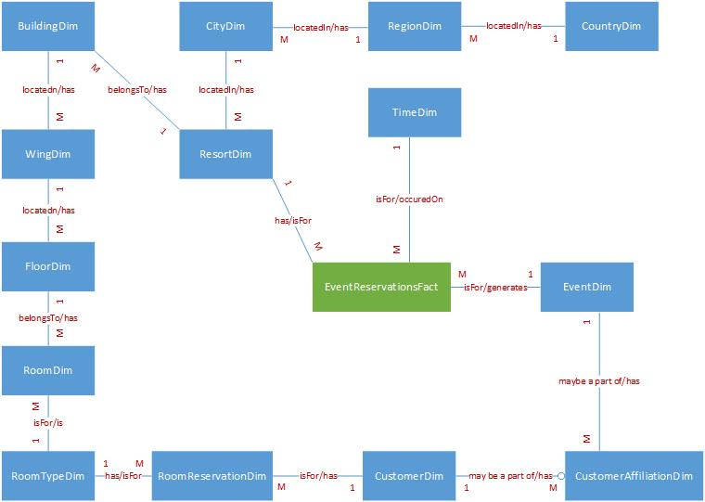

**b. Data Dictionary**

|  |  |  |  |  |  |  |
| --- | --- | --- | --- | --- | --- | --- |
| **Table Name** | **Description** |  |  |  |  |  |
| RoomTypeReservationsFact | This table contains one row for each room type reservation fact. |  |  |  |  |  |
|  |  |  |  |  |  |  |
| **Attribute Name** | **Attribute Description** | **PK** | **Data Type** | **Width** | **Range of Values** | **FK  Table** |
| C_TimeID_TR | Contains the foreign key from the TimeDim table. | Y | I | 9 | 0-999,999,999 | TI |
| T_RoomType_TR | Contains the foreign key from the RoomTypeDim table. | Y | T | 50 | A-Z | TR |
| C_ResortID_TR | Contains the foreign key from the ResortDim table. | Y | I | 9 | 0-999,999,999 | RS |
| N_TotalNumOfStays_TR | Contains the total number of stays. | N | N | 4 | 0-9,999 |  |
| N_TotalPrice_TR | Contains the total price of all stays. | N | N | 6 | 0-999,999 |  |

|  |  |  |  |  |  |  |
| --- | --- | --- | --- | --- | --- | --- |
| **Table Name** | **Description** |  |  |  |  |  |
| CustomerReservationsFact | This table contains one row for each customer reservation fact. |  |  |  |  |  |
|  |  |  |  |  |  |  |
| **Attribute Name** | **Attribute Description** | **PK** | **Data Type** | **Width** | **Range of Values** | **FK  Table** |
| C_TimeID_CR | Contains the foreign key from the TimeDim table. | Y | I | 9 | 0-999,999,999 | TI |
| C_CustomerID_CR | Contains the foreign key from the CustomerDim table. | Y | I | 9 | 0-999,999,999 | CU |
| C_ResortID_CR | Contains the foreign key from the ResortDim table. | Y | I | 9 | 0-999,999,999 | RS |
| N_TotalNumOfStays_CR | Contains the total number of stays. | N | N | 4 | 0-9,999 |  |
| N_TotalPrice_CR | Contains the total price of all stays. | N | N | 6 | 0-999,999 |  |

|  |  |  |  |  |  |  |
| --- | --- | --- | --- | --- | --- | --- |
| **Table Name** | **Description** |  |  |  |  |  |
| EventReservationsFact | This table contains one row for each event reservation fact. |  |  |  |  |  |
|  |  |  |  |  |  |  |
| **Attribute Name** | **Attribute Description** | **PK** | **Data Type** | **Width** | **Range of Values** | **FK  Table** |
| C_TimeID_ER | Contains the foreign key from the TimeDim table. | Y | I | 9 | 0-999,999,999 | TI |
| C_EventID_ER | Contains the foreign key from the EventDim table. | Y | I | 9 | 0-999,999,999 | EV |
| C_ResortID_ER | Contains the foreign key from the ResortDim table. | Y | I | 9 | 0-999,999,999 | RS |
| N_TotalNumOfStays_ER | Contains the total number of stays. | N | N | 4 | 0-9,999 |  |
| N_TotalPrice_ER | Contains the total price of all stays. | N | N | 6 | 0-999,999 |  |

|  |  |  |  |  |  |  |
| --- | --- | --- | --- | --- | --- | --- |
| **Table Name** | **Description** |  |  |  |  |  |
| TimeDim | This table contains one row for each time record. |  |  |  |  |  |
|  |  |  |  |  |  |  |
| **Attribute Name** | **Attribute Description** | **PK** | **Data Type** | **Width** | **Range of Values** | **FK  Table** |
| C_TimeID_TI | Contains a unique value for each instance of the TimeDim table. | Y | I | 9 | 0-999,999,999 |  |
| N_TimeYear_TI | Contains the year of the record. | N | I | 6 | 0-999,999 |  |
| N_TimeQuarter_TI | Contains the quarter of the record. | N | I | 1 | 1-4 |  |
| N_TimeMonth_TI | Contains the month of the record. | N | I | 2 | 1-12 |  |
| T_TimeDay_TI | Contains the day of the record. | N | T | 50 | A-Z |  |
| D_ClockTime_TI | Contains the full clock time. | N | D | 10 | 01-01-1000, 12-31-9999 |  |

|  |  |  |  |  |  |  |
| --- | --- | --- | --- | --- | --- | --- |
| **Table Name** | **Description** |  |  |  |  |  |
| RoomDim | This table contains one row for each room record. |  |  |  |  |  |
|  |  |  |  |  |  |  |
| **Attribute Name** | **Attribute Description** | **PK** | **Data Type** | **Width** | **Range of Values** | **FK  Table** |
| C_RoomNum_RM | Contains a unique value for each instance of the RoomDim table. | Y | T | 10 | A-Z |  |
| C_FloorNumber_RM | Contains the foreign key from the FloorDim table. | Y | I | 9 | 0-999,999,999 | FL |
| C_WingCode_RM | Contains the foreign key from the WingDim table. | Y | T | 10 | A-Z | WG |
| C_RoomType_RM | Contains the foreign key from the RoomTypeDim table. | N | T | 50 | A-Z | RT |

|  |  |  |  |  |  |  |
| --- | --- | --- | --- | --- | --- | --- |
| **Table Name** | **Description** |  |  |  |  |  |
| RoomTypeDim | This table contains one row for each room type record. |  |  |  |  |  |
|  |  |  |  |  |  |  |
| **Attribute Name** | **Attribute Description** | **PK** | **Data Type** | **Width** | **Range of Values** | **FK  Table** |
| C_RoomType_RT | Contains a unique value for each instance of the RoomTypeDim table. | Y | T | 50 | A-Z |  |
| N_RoomPrice_RT | Contains the price of each room type. | N | N | 6 | 0-999,999 |  |

|  |  |  |  |  |  |  |
| --- | --- | --- | --- | --- | --- | --- |
| **Table Name** | **Description** |  |  |  |  |  |
| RoomReservationDim | This table contains one row for each room reservation record. |  |  |  |  |  |
|  |  |  |  |  |  |  |
| **Attribute Name** | **Attribute Description** | **PK** | **Data Type** | **Width** | **Range of Values** | **FK  Table** |
| C_RoomReservationNum_RR | Contains a unique value for each instance of the RoomReservationDim table. | Y | T | 50 | A-Z |  |
| C_CustomerID_RR | Contains the foreign key from the CustomerDim table | Y | I | 9 | 0-999,999,999 | CU |
| C_RoomType_RR | Contains the foreign key from the RoomTypeDim table | Y | T | 50 | A-Z | RT |
| D_ArrivalDate_RR | Contains reservation’s arrival date. | N | D | 10 | 01-01-1000, 12-31-9999 |  |
| D_DepartureDate_RR | Contains reservation’s departure date. | N | D | 10 | 01-01-1000, 12-31-9999 |  |

|  |  |  |  |  |  |  |
| --- | --- | --- | --- | --- | --- | --- |
| **Table Name** | **Description** |  |  |  |  |  |
| FloorDim | This table contains one row for each floor record. |  |  |  |  |  |
|  |  |  |  |  |  |  |
| **Attribute Name** | **Attribute Description** | **PK** | **Data Type** | **Width** | **Range of Values** | **FK  Table** |
| C_FloorNumber_FL | Contains a unique value for each instance of the FloorDim table. | Y | I | 9 | 0-999,999,999 |  |
| C_BuildingID_FL | Contains the foreign key from the BuildingDim table. | Y | I | 9 | 0-999,999,999 | BU |
| C_WingCode_FL | Contains the foreign key from the WingDim table. | Y | T | 10 | A-Z | WG |
| **Table Name** | **Description** |  |  |  |  |  |
| WingDim | This table contains one row for each wing record. |  |  |  |  |  |
|  |  |  |  |  |  |  |
| **Attribute Name** | **Attribute Description** | **PK** | **Data Type** | **Width** | **Range of Values** | **FK  Table** |
| C_WingCode_WG | Contains a unique value for each instance of the FloorDim table. | Y | T | 10 | A-Z |  |
| C_BuildingID_WG | Contains the foreign key from the BuildingDim table. | Y | I | 9 | 0-999,999,999 | BU |
| T_WingName_WG | Contains the name for each wing. | N | T | 50 | A-Z |  |

|  |  |  |  |  |  |  |
| --- | --- | --- | --- | --- | --- | --- |
| **Table Name** | **Description** |  |  |  |  |  |
| BuildingDim | This table contains one row for each building record. |  |  |  |  |  |
|  |  |  |  |  |  |  |
| **Attribute Name** | **Attribute Description** | **PK** | **Data Type** | **Width** | **Range of Values** | **FK  Table** |
| C_BuildingID_BU | Contains a unique value for each instance of the BuildingDim table. | Y | I | 9 | 0-999,999,999 |  |
| T_BuildingName_BU | Contains the name for each building. | N | T | 50 | A-Z |  |
| T_BuildingDescription_BU | Contains the description for each building. | N | T | 255 | A-Z |  |
| C_ResortID_BU | Contains the foreign key from the ResortDim table. | N | I | 9 | 0-999,999,999 | RS |

|  |  |  |  |  |  |  |
| --- | --- | --- | --- | --- | --- | --- |
| **Table Name** | **Description** |  |  |  |  |  |
| ResortDim | This table contains one row for each resort record. |  |  |  |  |  |
|  |  |  |  |  |  |  |
| **Attribute Name** | **Attribute Description** | **PK** | **Data Type** | **Width** | **Range of Values** | **FK  Table** |
| C_ResortID_RS | Contains a unique value for each instance of the ResortDim table. | Y | I | 9 | 0-999,999,999 |  |
| T_ResortName_RS | Contains resort’s name. | N | T | 50 | A-Z |  |
| T_StreetAddress_RS | Contains resort’s street address. | N | T | 255 | A-Z |  |
| C_CityName_RS | Contains the foreign key from the CityDim table. | N | T | 50 | A-Z | CI |

|  |  |  |  |  |  |  |
| --- | --- | --- | --- | --- | --- | --- |
| **Table Name** | **Description** |  |  |  |  |  |
| CityDim | This table contains one row for each city record. |  |  |  |  |  |
|  |  |  |  |  |  |  |
| **Attribute Name** | **Attribute Description** | **PK** | **Data Type** | **Width** | **Range of Values** | **FK  Table** |
| C_CityName_CI | Contains a unique name for each instance of the CityDim table. | Y | T | 50 | A-Z |  |
| C_ZipCode_CI | Contains a unique zip code for each instance of the CityDim table. | Y | T | 50 | A-Z |  |
| T_State_CI | Contains city’s region. | N | T | 50 | A-Z |  |
| C_RegionID_CI | Contains the foreign key from the RegionDim table. | N | I | 9 | 0-999,999,999 | RG |

|  |  |  |  |  |  |  |
| --- | --- | --- | --- | --- | --- | --- |
| **Table Name** | **Description** |  |  |  |  |  |
| RegionDim | This table contains one row for each region record. |  |  |  |  |  |
|  |  |  |  |  |  |  |
| **Attribute Name** | **Attribute Description** | **PK** | **Data Type** | **Width** | **Range of Values** | **FK  Table** |
| C_RegionID_RG | Contains a unique name for each instance of the RegionDim table. | Y | I | 6 | 0-999,999 |  |
| T_RegionName_RG | Contains city’s region. | N | T | 50 | A-Z |  |
| C_CountryCode_RG | Contains the foreign key from the CountryDim table. | N | T | 5 | A-Z | CO |

|  |  |  |  |  |  |  |
| --- | --- | --- | --- | --- | --- | --- |
| **Table Name** | **Description** |  |  |  |  |  |
| CountryDim | This table contains one row for each country record. |  |  |  |  |  |
|  |  |  |  |  |  |  |
| **Attribute Name** | **Attribute Description** | **PK** | **Data Type** | **Width** | **Range of Values** | **FK  Table** |
| C_CountryCode_CO | Contains a unique name for each instance of the CountryDim table. | Y | T | 5 | A-Z |  |
| T_CountryName_CO | Contains country’s name. | N | T | 50 | A-Z |  |

|  |  |  |  |  |  |  |
| --- | --- | --- | --- | --- | --- | --- |
| **Table Name** | **Description** |  |  |  |  |  |
| EventDim | This table contains one row for each event record. |  |  |  |  |  |
|  |  |  |  |  |  |  |
| **Attribute Name** | **Attribute Description** | **PK** | **Data Type** | **Width** | **Range of Values** | **FK  Table** |
| C_EventID_EV | Contains a unique value for each instance of the EventDim table. | Y | I | 9 | 0-999,999,999 |  |
| T_EventDescription_EV | Contains event’s description. | N | T | 255 | A-Z |  |
| D_EventStartDate_EV | Contains event’s start date. | N | D | 10 | 01-01-1000, 12-31-9999 |  |
| D_EventEndDate_EV | Contains event’s end date. | N | D | 10 | 01-01-1000, 12-31-9999 |  |

|  |  |  |  |  |  |  |
| --- | --- | --- | --- | --- | --- | --- |
| **Table Name** | **Description** |  |  |  |  |  |
| CustomerDim | This table contains one row for each customer record. |  |  |  |  |  |
|  |  |  |  |  |  |  |
| **Attribute Name** | **Attribute Description** | **PK** | **Data Type** | **Width** | **Range of Values** | **FK  Table** |
| C_CustomerID_CU | Contains a unique value for each instance of the CustomerDim table. | Y | I | 9 | 0-999,999,999 |  |
| T_CustomerFirstName_CU | Contains customer’s first name. | N | T | 50 | A-Z |  |
| T_CustomerLastName_CU | Contains customer’s last name. | N | T | 50 | A-Z |  |
| T_CustomerMiddleName_CU | Contains customer’s middle name. | N | T | 50 | A-Z |  |
| T_CustomerAddress_CU | Contains customer’s address. | N | T | 255 | A-Z |  |
| I_CustomerPhoneNumber_CU | Contains customer’s phone number. | N | T | 50 | A-Z |  |

|  |  |  |  |  |  |  |
| --- | --- | --- | --- | --- | --- | --- |
| **Table Name** | **Description** |  |  |  |  |  |
| CustomerAffiliationDim | This table contains one row for each instance of a customer attending an event. |  |  |  |  |  |
|  |  |  |  |  |  |  |
| **Attribute Name** | **Attribute Description** | **PK** | **Data Type** | **Width** | **Range of Values** | **FK  Table** |
| C_CustomerID_CA | Contains the foreign key from the CustomerDim table. | Y | I | 9 | 0-999,999,999 | CU |
| C_EventID_CA | Contains the foreign key from the EventDim table. | Y | I | 9 | 0-999,999,999 | EV |

1. **MySQL DDL**

*--TimeDim*

**CREATE** **TABLE** TimeDim

(

C_TimeID_TI INT **PRIMARY** **KEY**,

N_TimeYear_TI INT **NOT** **NULL**,

N_TimeQuarter_TI INT **NOT** **NULL**,

N_TimeMonth_TI INT **NOT** **NULL**,

T_TimeDay_TI VARCHAR(50) **NOT** **NULL**,

D_ClockTime_TI DATETIME **NOT** **NULL**

);

*--RoomTypeDim*

**CREATE** **TABLE** RoomTypeDim

(

C_RoomType_RT VARCHAR(50) **PRIMARY** **KEY**,

N_RoomPrice_RT DECIMAL **NOT** **NULL**

);

*--CountryDim*

**CREATE** **TABLE** CountryDim

(

C_CountryCode_CO VARCHAR(5) **PRIMARY** **KEY**,

T_CountryName_CO VARCHAR(50) **NOT** **NULL**

);

*--RegionDim*

**CREATE** **TABLE** RegionDim

(

C_RegionID_RG INT **PRIMARY** **KEY**,

T_RegionName_RG VARCHAR(50) **NOT** **NULL**,

C_CountryCode_RG VARCHAR(5) **NOT** **NULL**,

**FOREIGN** **KEY** (C_CountryCode_RG) **REFERENCES** CountryDim(C_CountryCode_CO)

);

*--CityDim*

**CREATE** **TABLE** CityDim

(

C_CityName_CI VARCHAR(50),

C_ZipCode_CI VARCHAR(50),

T_State_CI VARCHAR(50) **NOT** **NULL**,

C_RegionID_CI INT **NOT** **NULL**,

**FOREIGN** **KEY** (C_RegionID_CI) **REFERENCES** RegionDim(C_RegionID_RG),

**PRIMARY** **KEY**(C_CityName_CI, C_ZipCode_CI)

);

*--ResortDim*

**CREATE** **TABLE** ResortDim

(

C_ResortID_RS INT **PRIMARY** **KEY**,

T_ResortName_RS VARCHAR(50) **NOT** **NULL**,

T_StreetAddress_RS VARCHAR(255) **NOT** **NULL**,

C_CityName_RS VARCHAR(50) **NOT** **NULL**,

**FOREIGN** **KEY** (C_CityName_RS) **REFERENCES** CityDim(C_CityName_CI)

);

*--BuildingDim*

**CREATE** **TABLE** BuildingDim

(

C_BuildingID_BU INT **PRIMARY** **KEY**,

T_BuildingName_BU VARCHAR(50) **NOT** **NULL**,

T_BuildingDescription_BU VARCHAR(255) **NOT** **NULL**,

C_ResortID_BU INT **NOT** **NULL**,

**FOREIGN** **KEY** (C_ResortID_BU) **REFERENCES** ResortDim(C_ResortID_RS)

);

*--WingDim*

**CREATE** **TABLE** WingDim

(

C_WingCode_WG VARCHAR(10) **NOT** **NULL**,

C_BuildingID_WG INT **NOT** **NULL**,

T_WingName_WG VARCHAR(50) **NOT** **NULL**,

**PRIMARY** **KEY**(C_WingCode_WG, C_BuildingID_WG)

);

*--FloorDim*

**CREATE** **TABLE** FloorDim

(

C_FloorNumber_FL INT **NOT** **NULL**,

C_BuildingID_FL INT **NOT** **NULL**,

C_WingCode_FL VARCHAR(10) **NOT** **NULL**,

**PRIMARY** **KEY**(C_FloorNumber_FL, C_BuildingID_FL, C_WingCode_FL)

);

*--RoomDim*

**CREATE** **TABLE** RoomDim

(

C_RoomNum_RM VARCHAR(10) **NOT** **NULL**,

C_FloorNumber_RM INT **NOT** **NULL**,

C_WingCode_RM VARCHAR(10) **NOT** **NULL**,

C_RoomType_RM VARCHAR(50) **NOT** **NULL**,

**PRIMARY** **KEY**(C_RoomNum_RM, C_FloorNumber_RM, C_WingCode_RM),

**FOREIGN** **KEY** (C_RoomType_RM) **REFERENCES** RoomTypeDim(C_RoomType_RT)

);

*--EventDim*

**CREATE** **TABLE** EventDim

(

C_EventID_EV INT **NOT** **NULL** **PRIMARY** **KEY**,

T_EventDescription_EV VARCHAR(255) **NOT** **NULL**,

D_EventStartDate_EV DATETIME **NOT** **NULL**,

D_EventEndDate_EV DATETIME **NOT** **NULL**

);

*--CustomerDim*

**CREATE** **TABLE** CustomerDim

(

C_CustomerID_CU INT **NOT** **NULL** **PRIMARY** **KEY**,

T_CustomerFirstName_CU VARCHAR(50) **NOT** **NULL**,

T_CustomerLastName_CU VARCHAR(50) **NOT** **NULL**,

T_CustomerMiddleName_CU VARCHAR(50),

T_CustomerAddress_CU VARCHAR(255),

I_CustomerPhoneNumber_CU VARCHAR(50) **NOT** **NULL**

);

*--CustomerAffiliationDim*

**CREATE** **TABLE** CustomerAffiliationDim

(

C_CustomerID_CA INT **NOT** **NULL**,

C_EventID_CA INT **NOT** **NULL**,

**FOREIGN** **KEY** (C_CustomerID_CA) **REFERENCES** CustomerDim(C_CustomerID_CU),

**FOREIGN** **KEY** (C_EventID_CA) **REFERENCES** EventDim(C_EventID_EV),

**PRIMARY** **KEY**(C_CustomerID_CA, C_EventID_CA)

);

*--RoomTypeReservationsFact*

**CREATE** **TABLE** RoomTypeReservationsFact

(

C_TimeID_TR INT **NOT** **NULL**,

T_RoomType_TR VARCHAR(50) **NOT** **NULL**,

C_ResortID_TR INT **NOT** **NULL**,

N_TotalNumOfStays_TR DECIMAL,

N_TotalPrice_TR DECIMAL,

**FOREIGN** **KEY** (C_TimeID_TR) **REFERENCES** TimeDim(C_TimeID_TI),

**FOREIGN** **KEY** (T_RoomType_TR) **REFERENCES** RoomTypeDim(C_RoomType_RT),

**FOREIGN** **KEY** (C_ResortID_TR) **REFERENCES** ResortDim(C_ResortID_RS),

**PRIMARY** **KEY**(C_TimeID_TR, T_RoomType_TR, C_ResortID_TR)

);

*--CustomerReservationsFact*

**CREATE** **TABLE** CustomerReservationsFact

(

C_TimeID_CR INT **NOT** **NULL**,

C_CustomerID_CR INT **NOT** **NULL**,

C_ResortID_CR INT **NOT** **NULL**,

N_TotalNumOfStays_CR DECIMAL,

N_TotalPrice_CR DECIMAL,

**FOREIGN** **KEY** (C_TimeID_CR) **REFERENCES** TimeDim(C_TimeID_TI),

**FOREIGN** **KEY** (C_CustomerID_CR) **REFERENCES** CustomerDim(C_CustomerID_CU),

**FOREIGN** **KEY** (C_ResortID_CR) **REFERENCES** ResortDim(C_ResortID_RS),

**PRIMARY** **KEY**(C_TimeID_CR, C_CustomerID_CR, C_ResortID_CR)

);

*--EventReservationsFact*

**CREATE** **TABLE** EventReservationsFact

(

C_TimeID_ER INT **NOT** **NULL**,

C_EventID_ER INT **NOT** **NULL**,

C_ResortID_ER INT **NOT** **NULL**,

N_TotalNumOfStays_ER DECIMAL,

N_TotalPrice_ER DECIMAL,

**FOREIGN** **KEY** (C_TimeID_ER) **REFERENCES** TimeDim(C_TimeID_TI),

**FOREIGN** **KEY** (C_EventID_ER) **REFERENCES** EventDim(C_EventID_EV),

**FOREIGN** **KEY** (C_ResortID_ER) **REFERENCES** ResortDim(C_ResortID_RS),

**PRIMARY** **KEY**(C_TimeID_ER, C_EventID_ER, C_ResortID_ER)

);